Death Will Be My Acquaintance
Whatever I could not bear to kill
Could this possibly be my last lunch?
For nothingness is against my will
I am not the last to lay the last punch

The reason of this wretched attack
Is to take away my last ever breath
For I will forever fade to black
It is tough to escape the creeping death

This is no use, I could not go fight
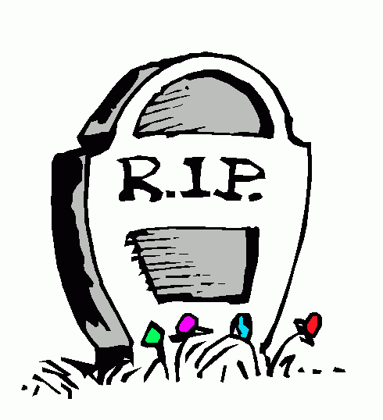
Of my last bleeding bloody strife
There it is now, I can see the light
It is now time to fight for my life.

At this moment, my soul will release
I am a dead man walking, rest in peace

