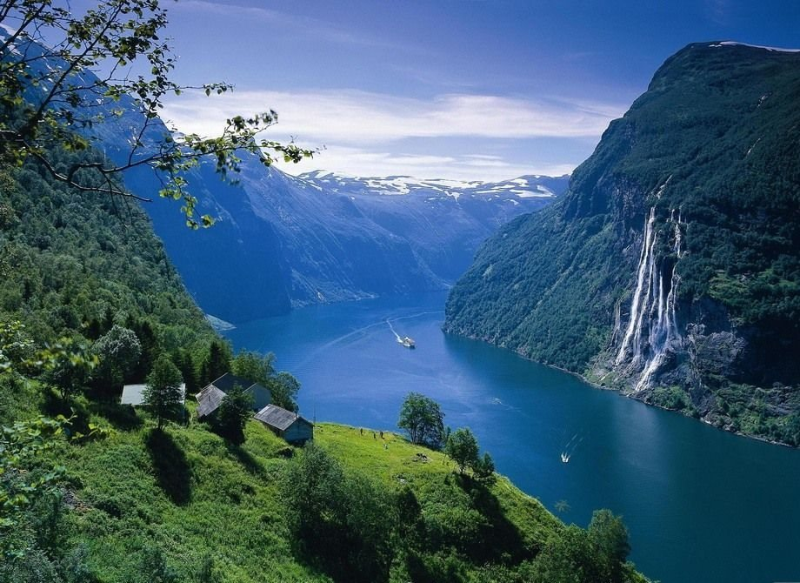
The Mystery of Beauty
Behold this wonderful and great sight
What a wonder for my very eyes
Looking at this place feels very right
So vibrant as the blue and high skies
As beautiful as the dark black night
Makes me feel the taste of a billion pies

Beauty is good for the mind and soul
Escapes me from my welcoming doom
This fills me up like a cereal bowl
With time, it shall blossom and bloom
With you baby, I have reached my goal

The ignorance of some is a distrust
Like a lion, I will hunt for you
This nature which is a definite must
Like a red flower, releasing dew
We humans reduced to stardust
A pinnacle of beauty? Sad but true.

